**Problem:**

Activity details:

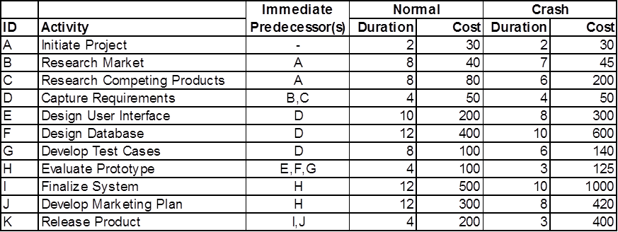

Indirect cost (administrative overhead fee): $2k / week

Constrains:

1. Project Duration: <= 42 weeks

(if > 42 weeks, fine: $1,000k;

if < 42 weeks, receive $200k bonus / week)

1. Budget: < $2,500k

**Solution:**

1. **“success” for this project:**
2. complete the project before the planned date (42 weeks) and under the budget ($2,500k)
3. reduce project duration as far as possible so as to minimize risks caused by unforeseen delay
4. don’t reduce project scope and compromise quality
5. **the precedence diagram for the "normal" schedule:**

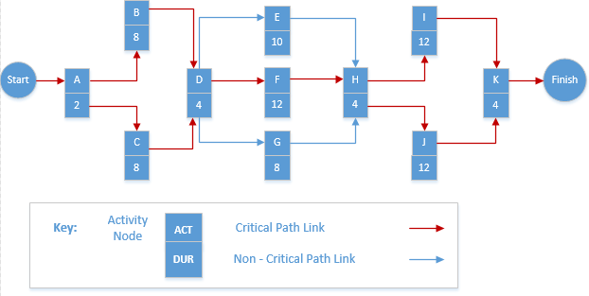

1. **Critical path for the "normal" schedule**:

A 🡪 B (or C) 🡪 D 🡪 F 🡪 H 🡪 I (or J) 🡪 K

1. **Expected project duration :**

2 (A) + 8 (B or C) + 4 (D) + 12 (F) + 4 (H) + 12 (I or J) + 4 (K) = 46 (weeks)

1. **Expected project costs:**

Indirect cost: $2k / week (administrative overhead fee) * 46 weeks = $92k

Direct cost: $30k (A) + $40k(B) + $80k(C) + $50k(D) + $200k(E) + $400k(F) + $100k(G) + $100k(H) + $500k(I) + $300k(J) + $200k(K) = $2,000k

Total cost = $92k + $2,000k = $2,092k

1. **Conclusion:**

Because this project is required to finish in 42 weeks (avoiding the fine of $1,000k) and the budget is less than $2,500k, this schedule is not good obviously which has the duration of 46 weeks. We need to reduce the duration of this project.

1. **Some advice:**

We need to reduce the duration to 42 weeks and keep the budget under $2,500k. We should compare the benefits of reducing project time with the cost and find the activities that can be shortened with smallest increase in cost per unit of time.

**First step: find the slope of activities allows us to compare which critical activities to shorten. Equation:** Cost Slope = (Crash Cost – Normal Cost) / (Normal Time – Crash Time)

Cost slope A = ($ 30K - $ 30K) / (2 -2) = $ 0K per unit of time

Cost slope B = ($ 45K - $ 40K) / (8 -7) = $ 5K per unit of time

Cost slope C = ($ 200K - $ 80K) / (8 -6) = $ 60K per unit of time

Cost slope D = ($ 50K - $ 50K) / (4 -4) = $ 0K per unit of time

Cost slope E = ($ 300K - $ 200K) / (10 -8) = $ 50K per unit of time

Cost slope F = ($ 600K - $ 400K) / (12 -10) = $ 100K per unit of time

Cost slope G = ($ 140K - $ 100K) / (8 -6) = $ 20K per unit of time

Cost slope H = ($ 125K - $ 100K) / (4 -3) = $ 25K per unit of time

Cost slope I = ($ 1000K - $ 500K) / (12 -10) = $ 250K per unit of time

Cost slope J = ($ 420K - $ 300K) / (12 -8) = $ 30K per unit of time

Cost slope K = ($ 400K - $ 200K) / (4 -3) = $ 200K per unit of time

**Cost-Duration Trade-Off**

|  |  |  |  |  |  |  |
| --- | --- | --- | --- | --- | --- | --- |
| **Activity ID** | **Slope** | **Max. crash time** | **Direct Cost** | | | |
| **Normal** | | **Crash** | |
| **Duration** | **Cost** | **Duration** | **Cost** |
| **A** | **0** | **0** | 2 | 30 | 2 | 30 |
| **B** | **5** | **1** | 8 | 40 | 7 | 45 |
| **C** | **60** | **2** | 8 | 80 | 6 | 200 |
| **D** | **0** | **0** | 4 | 50 | 4 | 50 |
| **E** | **50** | **2** | 10 | 200 | 8 | 300 |
| **F** | **100** | **2** | 12 | 400 | 10 | 600 |
| **G** | **20** | **2** | 8 | 100 | 6 | 140 |
| **H** | **25** | **1** | 4 | 100 | 3 | 125 |
| **I** | **250** | **2** | 12 | 500 | 10 | 1000 |
| **J** | **30** | **4** | 12 | 300 | 8 | 420 |
| **K** | **200** | **1** | 4 | 200 | 3 | 400 |

**Second step: find the smallest slope to short the duration.**

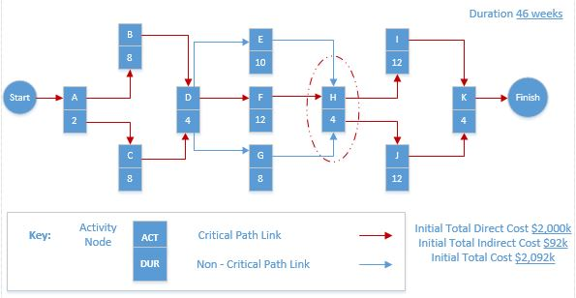

1. Critical path: A 🡪 B (or C) 🡪 D 🡪 F 🡪 H 🡪 I (or J) 🡪 K.

Activity H is circle because it is the least cost candidate; that is, its slope ($25k) is less than the slopes for activity B adding C ($5 + $60 = $65k).

Duration: H – 1 = 3 weeks

Direct Cost: H + $25k

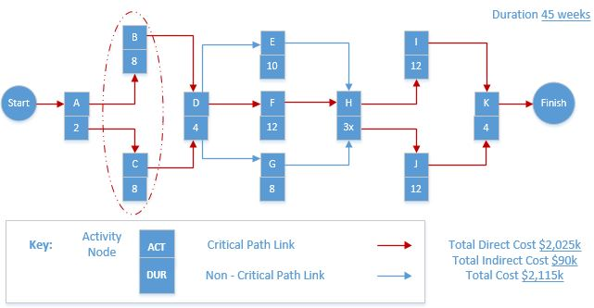

1. Critical path: A 🡪 B (or C) 🡪 D 🡪 F 🡪 H 🡪 I (or J) 🡪 K.

Activity B and C are circled because they are the least cost candidates; that is, their slopes ($5k + $60k = $65k) is less than the slopes for F ($100k).

Duration: B – 1 = 7 weeks; C – 1 = 7 weeks

Direct Cost: B + $5k; C + $60k

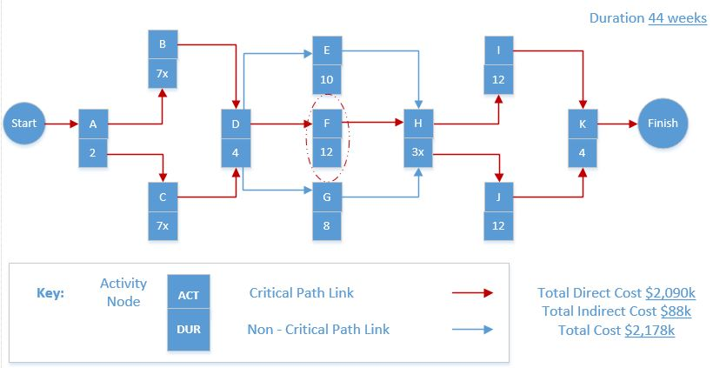

1. Critical path: A 🡪 B (or C) 🡪 D 🡪 F 🡪 H 🡪 I (or J) 🡪 K.

Activity F is circle because it is the least cost candidate; that is, its slope ($100k) is less than the slopes for activity K ($200k).

Duration: F – 1 = 11 weeks

Direct Cost: F + $100k

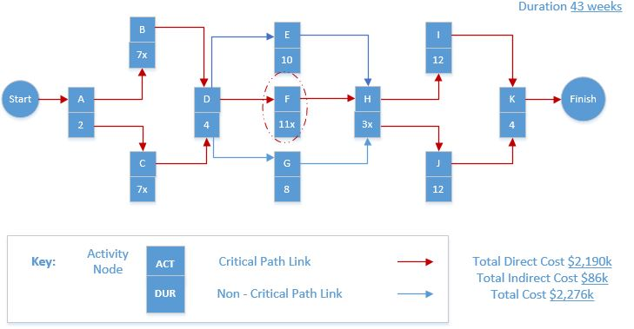

1. Critical path: A 🡪 B (or C) 🡪 D 🡪 F 🡪 H 🡪 I (or J) 🡪 K.

Activity F is circle because it is the least cost candidate; that is, its slope ($100k) is less than the slopes for activity K ($200k).

Duration: F – 1 = 10 weeks

Direct Cost: F + $100k

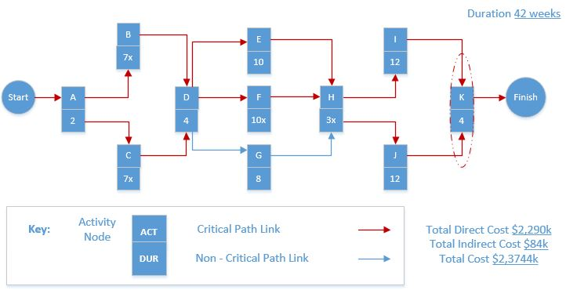

1. Critical path: A 🡪 B (or C) 🡪 D 🡪 E (or F) 🡪 H 🡪 I (or J) 🡪 K.

Activity K is circle because it is the least cost candidate; that is, its slope ($200k) is less than the slopes for activity I adding J ($250k + 30K).

Duration: K – 1 = 3 weeks.

Direct Cost: K + $200k.

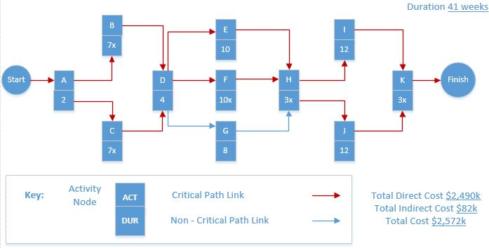

**Third step: draw a project cost-duration graph and the optimum cost-time point**

|  |  |  |  |
| --- | --- | --- | --- |
| **Project**  **Duration** | **Dir. Cost +** | **Indir. Cost =** | **Total Cost** |
| 46 | 2,000 | 92 | 2,092 |
| 45 | 2,025 | 90 | 2,115 |
| 44 | 2,090 | 88 | 2,178 |
| 43 | 2,190 | 86 | 2,276 |
| **42** | **2,290** | **84** | **2,374** |
| 41 | 2,490 | 82 | 2,572 |

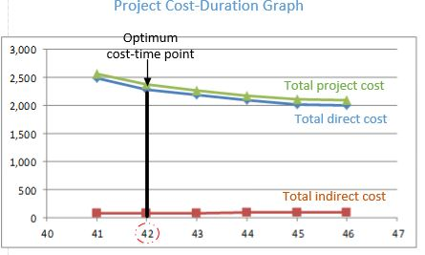

This graph shows that the optimum cost-time duration is 42 weeks and $2,372k (under the budget $2,500k).